**User Manual for ShinyRFU()**

**Peter Gill**

1. **Introduction**

The ShinyRFU() program is in file: ShinyRFU_0.2.0.tar.gz (latest version uploaded 3/11/2022) which is located at <https://github.com/peterdgill/ShinyRFU> The program itself is written in R and it utilises EuroForMix <http://www.euroformix.com/> in the background in order to carry out the calculations. There is a user friendly gui interface incorporated, that is programmed in R-Shiny <https://shiny.rstudio.com/>. It is not intended as a replacement for EuroForMix as it has no exploratory capability: it is primarily intended to provide a quick method to calculate average RFU value and associated mixture proportion (*Mx*) values. If there are a large number of samples to analyse, they can be concatenated into a single file and analysed in a single run – this is a considerable time saving.

Note that v.0.1.1 has a bug that causes the program to crash when the Cond information is missing (which will always be true with the direct transfer experiment 1)

1. **Loading ShinyRFU() into R**

The following steps are only undertaken for the version of R that you are using (current implementation is R4.2.2. at time of writing)

If you don’t have R then download it:

Download R <https://cran.r-project.org/bin/windows/base/> and Rtools from the CRAN website <https://cran.r-project.org/bin/windows/Rtools/> , following the instructions on the website.

Once loaded, open R and set the CRAN mirror from the R console menu: "Packages>set CRAN mirror" (fig 1).

**Step 1:** Load packages: Set the CRAN mirror by navigating to Packages>Set CRAN mirror (fig 1) and choose a connection. Copy/paste the following code into the R console, press return. This step only needs to be carried out once for the version of R that you are using.

Copy/paste commands below into the R console:

install.packages("devtools")

To install euroformix (latest version 4.0.1) load the following packages (use copy/paste):

install.packages(c('gWidgets2tcltk','forensim','cubature','XML','curl','plotly', 'shiny','shinybusy'))

Install euroformix() as follows:

install.packages('<http://euroformix.com/sites/default/files/euroformix_4.0.1.zip>',repos=NULL,type='win.binary')

Create a working folder "AveRFU" (or some other name is OK) in your computer where will carry out your work. A different folder can be created as a working folder where data output can be collected (no formal requirements here).

Set the working directory to where the folders are located. File>change dir

Place the source program in your working folder “AveRFU”. Download file “

In the R-window navigate to Packages>Install packages from local files (fig 1) and navigate to the folder (currently in "AveRFU" containing the source program "ShinyRFU_0.1.1.tar.gz" which you can obtain from <https://www.dropbox.com/s/2qzxkg4l0u7w6a8/ShinyRFU_0.2.0.tar.gz?dl=0>

Or from github: at <https://github.com/peterdgill/ShinyRFU>

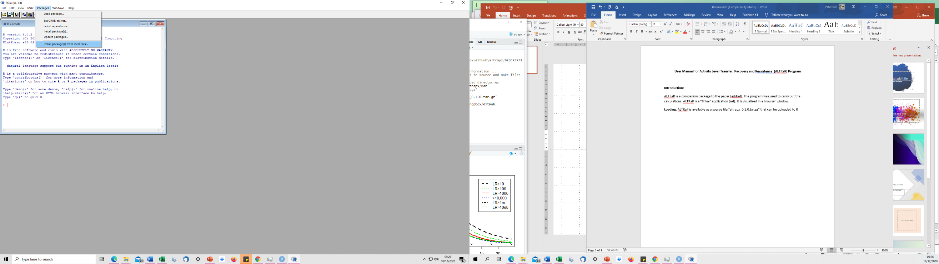

Fig 1: R console: load packages

In the R console type:

library(ShinyRFU)

The package should now be loaded.

**(Step 1 only needs to be done once provided the same R version is subsequently used).**

1. **Running Shinyrfu()**

In the R console type:

ShinyRFU()

Then the Gui appears in your browser (fig 2).

Fig. 2: ShinyRFU Gui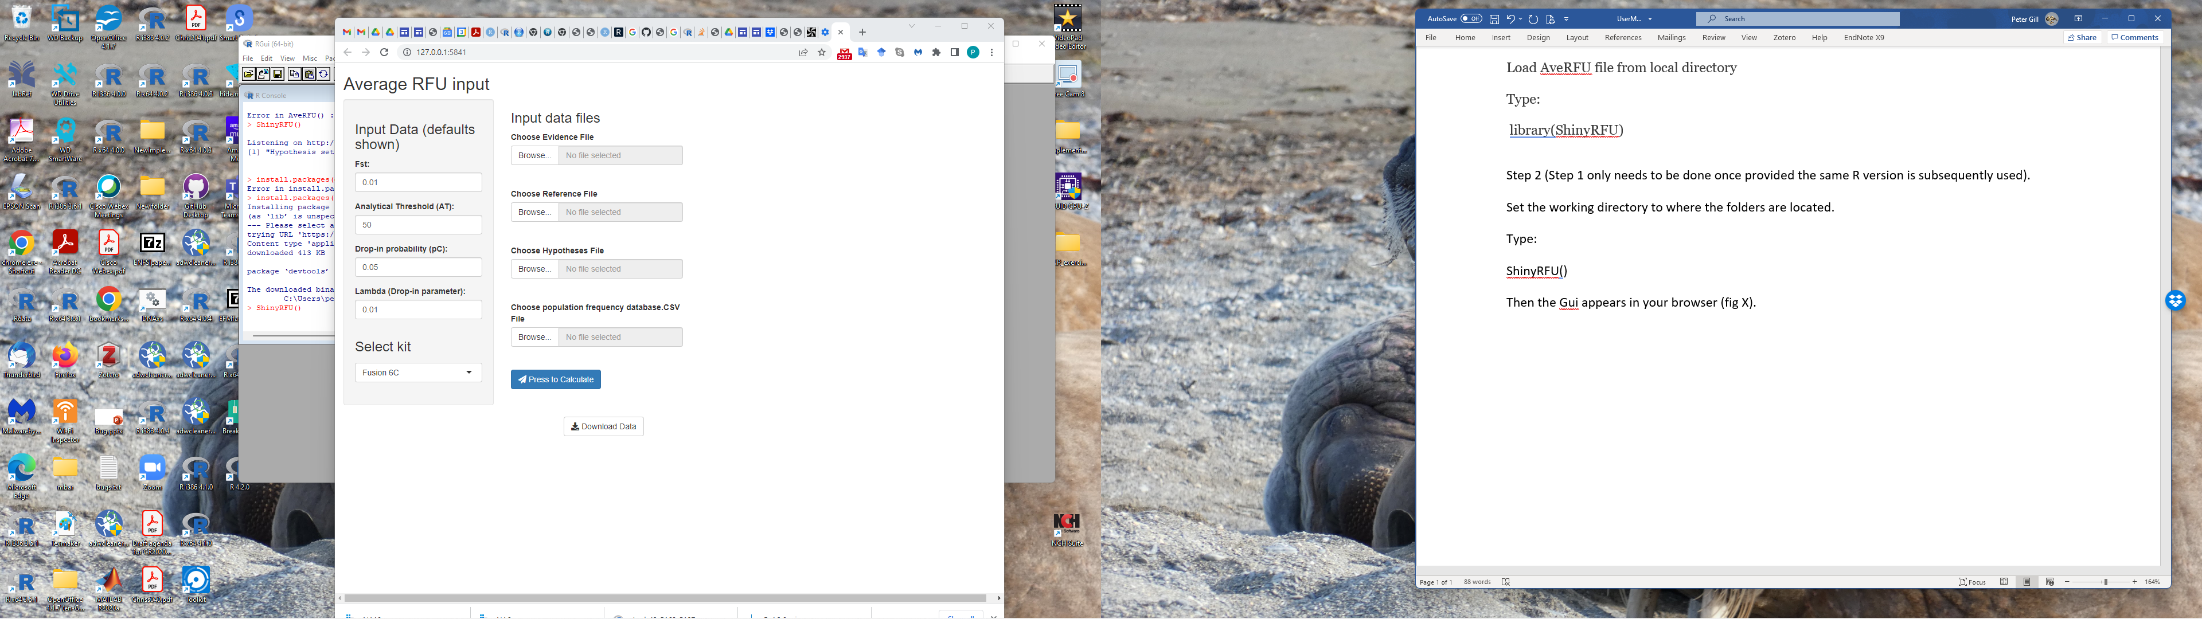

Input the requested data (or use default values). The evidence, reference and population frequency data files are selected using file explorer (fig 3). The kit name must be selected from the drop-down box.

Then press the blue 'calculate; button and the 'busy' icon will appear. If a large number of cases are examined, the time to calculate will be quite lengthy. There is no error trapping in this version: **click on the console window to check progress**. If everything is going well then you will see a message "[1] "Hypothesis set #1". For multiple tests the number will advance. If there is an error message, then escape the program by pressing the 'esc' key whilst still in the console window. The program cycles through 3 different models per hypothesis: a) No stutter b) Back- stutter only c) Back and forward stutter; the best model is automatically chosen for display.

When the program has finished running, then the busy icon will disappear, and you can now select the "Download Data" button and download the generated data-file to the folder of your choice using file explorer. As a back-up, a file which called "ResultsFIle" is automatically written to the working directory as soon as the calculation is completed. This is useful if the gui is accidentally closed down or timed out before the user is able to download the data.

If you are not sure what your working directory is then type: getwd() in the console.

Once you have downloaded the data, you can either load different files and run again, or you can terminate the program by pressing the "esc" key whilst in the console. The browser window will be greyed out and can be deleted.

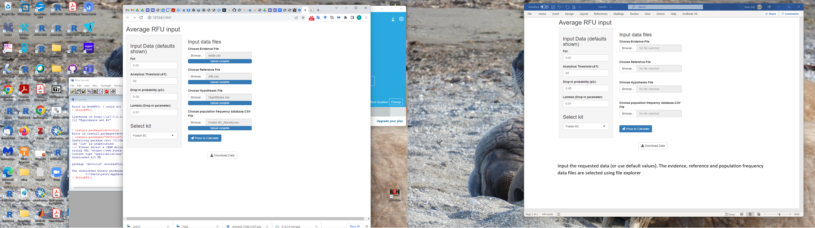

Fig 3: Data loaded – press calculate button to analyse data

1. **Explanation of the input data files:**

The data-files must follow a specific structure. Examples are provided in the folder "AveRFU". They can either be in .csv or .txt format. They should be constructed using GeneMapper using the method shown in the GeneMapper folder provided. This format will work for both EuroForMix and DNAxs.

**N.B. The names in the top row must be as shown. Loci names in the three data files must all be identical per locus. Always cut and paste identifiers from a source that you know works.**

Four files are needed to run ShinyRFU() (hypotheses, evidence, reference and population frequency data files). The evidence, reference and population frequency files follow the standard EuroForMix format.

* 1. **Data file input:**

1. Hypotheses file:



A sample name is provided, along with the POI and the conditioned individual (Cond), along with number of contributors (NOC).

$$LR=\frac{B1+B2}{U+B2}$$

Where U=unknown contributor

If NOC=3 then: $$LR=\frac{B1+B2+U}{U+U+B2}$$

Multiple rows can be provided if there are multiple samples so that all calculations will be completed concurrently and the results appear in a single file

Note that for experiment 1, the Cond information should be left blank, because we are only interested in the POI information. If unknown individuals are present then the NOC is adjusted accordingly.

1. Evidence file:



1. Reference file



1. Population data file (Only a small portion is shown):



Evidence and reference files can combine multiple samples in one file – no need to carry out multiple runs with ShinyRFU().

1. **Output from ShinyRFU program**

The output is generated as a file that can be opened using excel. Columns are delimited with semi colons (;) and the text import wizard will import the data. There is a lot of useful information in this file which will be used to estimate DNA quantities per individual contributor.

Column headings are as follows:

From the hypothesis file:

1. Sample Name
2. POI
3. Cond (the conditioned sample under Hp and Hd) if present
4. NOC: Number of contributors (from the hypothesis file)

EuroFormix calculations

1. Loglikhp: The log likelihood under Hp
2. Loglikhd: The log likelihood under Hd
3. LRmle: The mle likelihood ratio
4. thetaHp/Hd: 

There are 6 values shown under each. The first two are **Mx (Cond) Mx (POI) (note the order is fixed)**. If there are three contributors then a third value will be shown corresponding to the unknown contributor (similarly if there are four contributors then an additional unknown is listed). **If there is no individual conditioned (i.e no Cond) then the first Mx is POI and the second is Unknown and so on.** In the example shown, the 3rd-6th values are: i peak height expectation; ii peak height variability; iii. Degradation slope; I, iv. BW stutter (we will not be using this data in the first analysis but it may be useful for longer term analysis so it should be collected and maintained). For the current work, only the Mx values are of interest and will be forwarded to the main data spreadsheet (described below). **Be sure to use the Mx values from thetaHp as we work under the sub-source assumption that Hp=true** (also these samples are from known contributors)

1. MAC: is the matching allele count for the POI and Cond (compared to the evidence)
2. nDropout: are the number of missing alleles compared to the evidence for POI and Cond
3. nAunknown: Are the number of unknown alleles recorded that are neither found in the POI nor Cond.
4. nRefAlleles: is the allele count for POI and Cond.
5. nAlleles: is the total number of alleles in the evidence
6. avgRFU: is the average RFU value (to be multiplied by Mx for POI and Cond to apportion)